Hybrid Deep Learning Model for Depth of Anaesthesia Estimation using Electroencephalogram
Shoaib Shahriar Ibrahim ^{a, †}, Majidul Islam Chowdhury ^{a, †}, Md. Ashikur Rahman ^{a, †}, Rafsan Jany ª, Md Azam Hossain ^{a, *}, Iqram Hussain ^{b, *}

ª Department of Computer Science and Engineering, Islamic University and Technology (IUT), Gazipur, Bangladesh.
^{b} Department of Anesthesiology, Weill Cornell Medicine, Cornell University, New York, NY 10065, USA

Keywords: cardiovascular disease, electrocardiogram, arrhythmia, ischemia, interpretability.

*Corresponding email: iqh4001@med.cornell.edu, azam@iut-dhaka.edu

† Authors have equal contributions.

Abstract
Background and Objective: Monitoring the depth of anesthesia (DoA) is crucial for patient safety during surgeries, as inadequate anesthesia can lead to intraoperative awareness, while excessive anesthesia increases the risk of postoperative complications . Traditional methods, such as the Bispectral Index (BIS), have limitations in accurately predicting DoA due to the complexity of EEG signals. This study proposes an advanced DoA prediction framework using deep learning models applied to EEG signals, aiming to enhance prediction accuracy and reliability.
Methods: We utilized the VitalDB[1] dataset, comprising EEG and BIS signals from surgical patients, to train and evaluate three deep learning models: BiLSTM, CNN+BiLSTM, and ResNet. Rigorous preprocessing, including a fourth-order bandpass filter, was applied to EEG signals, and invalid segments were excluded based on EEG impedance and BIS values. The models were tested on two EEG signal parameters (BIS/EEG1_WAV and BIS/EEG2_WAV) with a sampling rate of 128 Hz. Performance metrics, including Mean Absolute Error (MAE), Mean Squared Error (MSE), Root Mean Squared Error (RMSE), and R² score, were used to assess predictive accuracy. We also explored the classification of anesthesia levels into four categories using a balanced and imbalanced dataset.
Results: The CNN+BiLSTM model demonstrated superior performance, achieving the lowest MAE of 4.37. The BiLSTM model, achieved an accuracy of 0.75 on imbalanced data and after applying Synthetic Minority Over-sampling Technique (SMOTE) achieved 0.698 on balanced data for classifying anesthesia levels. The findings highlight the effectiveness of deep learning models in capturing complex EEG patterns, leading to improved BIS predictions and anesthesia level classification. The classification results highlighted the models' ability to categorize anesthesia levels effectively, with the CNN+BiLSTM model also showing strong performance in this domain.
Conclusions: The proposed deep learning-based DoA monitoring framework shows significant promise in enhancing the accuracy and reliability of anesthesia management. The application of CNN+BiLSTM models, in particular, offers a robust tool for predicting BIS and classifying anesthesia levels, potentially improving patient outcomes. The study's approach also underscores the importance of addressing data imbalance and model interpretability in clinical applications.

Introduction
During surgery, a highly coordinated process ensures patient safety and comfort: the surgeon performs the operation, while anesthesia drugs maintain the patient in a controlled state of unconsciousness, preventing pain and movement [2], [3], [4]. Achieving the optimal depth of anesthesia (DoA) is critical, as it balances the need for unconsciousness with the patient’s physiological well-being [5], [6]. Insufficient anesthesia can lead to "accidental awareness," a potentially traumatic experience where patients regain consciousness during surgery [7]. On the other hand, excessive anesthesia can suppress vital functions, increasing the risk of complications during recovery.
With millions of surgeries conducted daily worldwide, effective anesthesia management is crucial. Traditional methods for monitoring DoA, such as heart rate and blood pressure observations, provide indirect assessments that often lack the sensitivity needed for complex surgical cases [8]. Studies have shown that these conventional methods can lead to inaccurate DoA estimations in up to 20% of surgeries [9]. Furthermore, physiological parameters like heart rate can be affected by factors unrelated to anesthesia depth, further complicating assessments.
To overcome these challenges, advanced techniques like the Bispectral Index (BIS) have been developed. BIS, derived from electroencephalogram (EEG) signals, provides a more direct measure of brain activity under anesthesia by analyzing the frequency, amplitude, and phase of EEG waves to generate a numerical index between 0 (deep anesthesia) and 100 (fully awake) [10], [11]. Despite its widespread use in clinical settings, BIS has its limitations. The proprietary algorithm behind BIS raises concerns about transparency, and simplifying complex brain states into a single index may not fully capture the neurological nuances of anesthesia.

EEG-based monitoring offers a continuous and direct measurement of brain activity, making it a valuable tool for assessing anesthesia's effects on the central nervous system [12], [13]. However, the complexity of EEG signals—rich in both temporal and spatial information—poses challenges for traditional algorithms, which may not fully exploit the data [14]. This has led to growing interest in applying advanced techniques, such as deep learning, to improve EEG-based DoA monitoring [15].
Deep learning, a powerful subset of machine learning, excels in analyzing complex datasets like EEG signals [16], [17]. Unlike traditional models that require manual feature extraction, deep learning models such as Convolutional Neural Networks (CNNs) and Long Short-Term Memory (LSTM) networks can automatically learn and extract meaningful patterns from raw data [18], [19]. CNNs are effective at capturing spatial features, while LSTMs excel at modeling temporal dependencies [20]. These characteristics make deep learning models particularly suited for DoA monitoring, where both spatial and temporal EEG patterns must be interpreted [21].
Despite the potential of deep learning to revolutionize anesthesia management, its application in this field is still in its early stages. Challenges include the need for large, diverse datasets and the development of interpretable models that clinicians can rely on [17]. Nonetheless, the integration of deep learning with EEG-based DoA monitoring holds significant promise for improving the accuracy and reliability of anesthesia management.
This study addresses current limitations in DoA prediction by developing and evaluating a series of deep learning models, including BiLSTM, CNN+BiLSTM, and ResNet architectures, using EEG data from the VitalDB dataset [22], [23]. These models aim to predict BIS values and classify anesthesia levels based on EEG signals. The VitalDB dataset provides a comprehensive source of real-world clinical EEG and BIS data, making it suitable for training and testing the proposed models [1]. Rigorous preprocessing, including the application of a fourth-order bandpass filter and exclusion of invalid segments, ensures high-quality input data. Model performance is evaluated using key metrics such as Mean Absolute Error (MAE), Mean Squared Error (MSE), Root Mean Squared Error (RMSE), and R² scores.
The study’s findings demonstrate the effectiveness of deep learning models, particularly the CNN+BiLSTM model, in predicting BIS and classifying anesthesia levels. The study also classifies anesthesia into four distinct classes—Deep Anesthesia (BIS: 0-40), General Anesthesia (BIS: 40-60), Light Sedation (BIS: 60-80), and Awake (BIS: 80-100)—using the BiLSTM model. These results suggest that deep learning models can significantly improve the accuracy and reliability of DoA monitoring, surpassing traditional methods. The key contributions of this research are as follows:
- This research provides a comprehensive analysis of deep learning techniques applied to EEG-based DoA prediction, demonstrating their potential to enhance traditional anesthesia monitoring methods.
The insights gained from this research will inform the development of more accurate and reliable DoA monitoring systems, ultimately contributing to safer and more effective anesthesia care. Future research should focus on improving model interpretability and enhancing their generalizability across diverse patient populations and surgical procedures.

Challenges and Progress in Depth of Anesthesia Monitoring
Research on predicting anesthesia depth using EEG signals has seen significant advances through both traditional and deep learning methods. Early studies employed Convolutional Neural Networks (CNNs) and Bidirectional Long Short-Term Memory (BiLSTM) networks with attention mechanisms to estimate the Bispectral Index (BIS) from EEG data [24]. These models demonstrated the ability to capture both spatial and temporal patterns in EEG signals, leading to improved BIS estimation accuracy. However, the reliance on specific EEG features limited the generalizability of these methods across diverse patient populations and surgical scenarios. Further progress was made with the use of Ensemble Empirical Mode Decomposition (EEMD) combined with CNNs [25]. This approach decomposed EEG signals into intrinsic mode functions, leading to high predictive accuracy. Despite its success, the method faced challenges related to variations in EEG characteristics due to different anesthesia protocols and patient-specific factors, which affected its robustness. Other studies have explored multimodal approaches, such as combining ResNet with arterial blood pressure (ABP) and EEG signals to predict intraoperative hypotension, an important indicator of anesthesia depth [26]. While integrating multiple physiological signals showed potential for improving prediction accuracy, the complexity of selecting relevant waveforms and integrating heterogeneous data sources posed significant challenges for real-world applications.
Hybrid models have also been proposed, such as those combining Long Short-Term Memory (LSTM) networks with Stacked Denoising Autoencoders (SDAEs) [27], [28]. These models aimed to reduce the noise and variability inherent in EEG signals, improving prediction accuracy. However, generalization across different surgical procedures remained difficult, as EEG signal characteristics varied widely depending on anesthesia depth and surgical type. Additionally, some studies have investigated the use of non-EEG signals for anesthesia prediction, such as using CNNs trained on electrocardiogram (ECG) and photoplethysmogram (PPG) signals [29]. Although these methods showed promise, they were limited by small training datasets and the computational demands of real-time processing.
In summary, while various methods have been proposed to predict anesthesia depth using EEG and other physiological signals, challenges remain in fully capturing the complex temporal dynamics and managing variability across different surgical contexts and patient populations.

Methodology
Our methodology involves a comprehensive approach to analyzing EEG signals through both regression and classification tasks. We begin by processing the dataset, which includes preprocessing to handle noise and normalization. For regression, we employ a CNN-BiLSTM hybrid model, designed to extract spatial features and capture temporal dependencies, providing accurate predictions of continuous EEG data. For classification, we compare BiLSTM and ResNet models to classify different anesthesia levels, addressing class imbalance using techniques like SMOTE and under sampling [30], [31]. This dual approach ensures thorough analysis, leveraging advanced models and preprocessing strategies to achieve robust and accurate results.

Dataset Overview
The study utilized the VitalDB[1] dataset, which includes comprehensive intraoperative bio signals and clinical data from 6,388 patients who underwent non-cardiac surgeries at Seoul National University Hospital. This dataset offers high-resolution waveform signals recorded at 500 Hz and numeric values captured at intervals ranging from 1 to 7 seconds, along with over 60 types of surgery-related clinical information. In total, the dataset comprises 557,622 data tracks, averaging 2.8 million data points per case. For the research, specific focus was placed on EEG signals, namely BIS/EEG1_WAV and BIS/EEG2_WAV. Data selection adhered to stringent criteria: cases with a duration of more than 30 minutes, patients aged 18 years or older, and the presence of both BIS and EEG data. Missing BIS values were forward-filled up to 7 seconds to maintain data continuity.

Experimental Setup
The experimental setup for this study is meticulously structured to ensure accurate data acquisition, processing, and analysis. The EEG tracks used for this experiment are BIS/EEG1_WAV and BIS/EEG2_WAV, with a segment rate set at 128 Hz. Each segment is defined by a length of four times the segment rate. The inclusion and exclusion criteria for the dataset include age, track names, and the use of anesthetic medication to ensure a homogeneous sample. A fourth-order bandpass filter is applied to the data to ensure signal clarity. For data filtering and processing, BIS values greater than 0 are considered valid, and the length of the case data must exceed 30 minutes. Invalid segments are excluded based on specific criteria: EEG impedance values greater than 12 and maximum EEG values less than 100 are deemed valid. Three models are utilized for this study: BiLSTM, CNN+BiLSTM, and CNN, lever aging the computational power of GPUs including RTX 3050, 3060, and 3090. The experimental setup is supported by a system with 64 GB RAM and processors ranging 32 from Core-i5 to Core-i9 11th generation, ensuring robust performance and efficiency in data processing and model training

Preprocessing

EEG Data Preprocessing
In the EEG preprocessing phase of the research, a comprehensive approach was adopted to ensure the quality and relevance of the EEG data for BIS prediction. The process involved several critical steps: To remove baseline drift and high-frequency noise, a bandpass filter was applied to the EEG signals. The filter was designed with cutoff frequencies of 0.5 Hz and 50 Hz, which were chosen to capture the relevant frequency range of EEG signals while excluding noise. The mathematical equation of the ideal bandpass filter, based on the specified cutoff frequencies, was derived as follows:
$$\begin{aligned}H\left(s\right)=K*\frac{ω_{ο}^{2}}{s^{2}+\frac{ω_{ο}^{2}}{Q}s+ω_{ο}^{2}} \#\left(1\right)\end{aligned}$$
Here: K is the gain of the filter. It determines the amplitude scaling of the output signal relative to the input signal. Specifically, K sets the maximum gain of the filter at the center frequency ω. S is the Laplace variable. The Laplace variable allows the analysis of systems in the frequency domain. It combines both the real part which represents growth/decay, and the imaginary part. $ω_{ο}$ is the center frequency of the passband. It is the frequency at which the filter's response is maximized. The filter allows frequencies around $ω_{ο}$to pass with minimal attenuation while attenuating frequencies far from $ω_{ο}$. Q is the quality factor or damping ratio of the filter. The quality factor Q measures the selectivity or sharpness of the filter. It is defined as the ratio of the center frequency ω0 to the bandwidth (BW) of the filter. The center frequency ω₀ is calculated as the geometric mean of the lower and upper cutoff frequencies:
$$\begin{aligned}ω_{ο}=\sqrt{f_{low}*f_{high}} \#\left(2\right)\end{aligned}$$
Given the specified cutoff frequencies of 0.5 Hz and 50 Hz, ω₀ was computed as:
${ ω}_{ο}=\sqrt{0.5×50}=5 rad/s$
The quality factor Q is often chosen to achieve a desired trade-off between bandwidth and filter response sharpness. For simplicity Q was set to 1. Substituting these values into the transfer function equation the mathematical equation of the ideal bandpass filter with cutoff frequencies of 0.5 Hz and 50 Hz, suitable for EEG signal preprocessing was got:
$\begin{aligned}H\left(s\right)=K*\frac{25}{s^{2}+5s+25} \#\left(3\right)\end{aligned}$
It describes the filter's behavior in the Laplace domain.

Segmentation
EEG signals were segmented into fixed-length windows of (4 x SRATE) samples, where (SRATE = 128) Hz. For a signal length of 4 seconds with sampling rate 128hz where each segment has 512 data points each. This segmentation approach was chosen to facilitate the analysis of EEG signals in a manageable format, allowing for the extraction of meaningful features for BIS prediction.

Artifact Handling
BIS values of 0 were excluded from the dataset to mitigate artifacts resulting from signal loss. This step was crucial for ensuring the reliability of the data and the validity of the subsequent analysis.

Data Validation
After filtering, a series of validations were performed on the EEG data to ensure its quality and relevance for the research objectives. These validations included checking for the presence of NaN values, performing an EEG impedance check, and identifying noisy samples. Only segments that passed these validations were retained for further analysis.

Regression Model
In this study, several deep learning models were evaluated to predict the Bispectral Index (BIS) from EEG data, aiming to improve the accuracy and reliability of anesthesia depth monitoring. The following models were considered:

CNN Model
Convolutional neural networks (CNNs) excel in encoding spatial features in sequential data like time series or text. By applying convolutional layers, CNNs extract and identify localized patterns, building hierarchical representations from lower to higher-level abstractions. Through convolution, pooling operations, and non-linear activations, CNNs progressively capture complex patterns, improving performance. Max-pooling reduces dimensionality, mitigating overfitting and computational demands while preserving essential features. CNNs' local connectivity and shift-invariance make them well-suited for detecting patterns in sequences, enhancing robustness to variations and noise. The CNN model follows the following equation for the i-th conventional layer:
$$\begin{aligned}z_{i}^{\left(l\right)}\left[n\right]=\sum_{k=0}^{K_{i}-1}{w_{i,k}^{\left(l\right)}}*x\left[n+k\right]+b_{i}^{\left(l\right)} \#\left(4\right)\end{aligned}$$
This equation describes the convolution operation in the i-th convolutional layer of the CNN. Here, x denotes the input sequence data. $z_{i}^{\left(l\right)}\left[n\right]$ is the output of the convolution operation at position n in the l-th layer. $w_{i,k}^{\left(l\right)}$ represents the weights (filter) used in the convolution operation for the i-th filter at the k-th position. $x\left[n+k\right]$ is the input sequence at position n+k. $b_{i}^{\left(l\right)}$ is the bias term for the iii-th filter in the l-th layer. $\sum_{k=0}^{K_{i}-1}{}$represents the sum over all the filter weights applied to the input sequence. Activation function (commonly ReLU) is defined as:
$$\begin{aligned}a_{i}^{\left(l\right)}\left[n\right]=\max\left(0,z_{i}^{\left(l\right)}\left[n\right]\right) \#\left(5\right)\end{aligned}$$
This equation describes the application of the Rectified Linear Unit (ReLU) activation function to the output of the convolution operation. $a_{i}^{\left(l\right)}\left[n\right]$is the output of the ReLU activation function for the iii-th filter at position n in the l-th layer. $z_{i}^{\left(l\right)}\left[n\right]$ is the input to the ReLU function, which is the result of the convolution operation. Max pooling operation is defined as:
$$\begin{aligned}p_{i}^{\left(l\right)}\left[n\right]=\max_{m=n}^{n+S_{i}-1}\left(a_{i}^{\left(l\right)}\left[n\right]\right) \#\left(6\right)\end{aligned}$$
This equation describes the max pooling operation applied to the output of the ReLU activation function. Where, $z_{i}^{\left(l\right)}\left[n\right]$ is the output of the conventional layer i at position n, $w_{i,k}^{\left(l\right)}$is the weight of the k-th filter in the layer i, $b_{i}^{\left(l\right)}$ is the bias term, $a_{i}^{\left(l\right)}\left[n\right]$ is the activation value at position n after applying the ReLU activation function, $p_{i}^{\left(l\right)}\left[n\right]$ is the output after max pooling, $K_{i}I$ is the kernel size of the convolution layer, $S_{i}$ is the stride of the max pooling layer. $p_{i}^{\left(l\right)}\left[n\right]$ is the result of the max pooling operation for the i-th filter at position n in the l-th layer. $a_{i}^{\left(l\right)}\left[n\right]$ is the output of the ReLU activation function. The max pooling operation takes the maximum value over a window of size S_{i} starting from position n to n+S_{i}-1

Bi LSTM Model
Bidirectional Long Short-Term Memory (BiLSTM) networks are pivotal in EEG signal analysis, leveraging their bidirectional processing to extract features, capture temporal dependencies, and generate accurate predictions. By processing EEG data in both forward and backward directions, BiLSTM discern subtle patterns and complex temporal dependencies, effectively modeling the intricate dynamics of neural processes. They systematically extract significant features, capturing unique patterns and transient events indicative of cognitive processes or brain states. These features are then used for predictive tasks, such as forecasting, event detection, and state classification, enhancing the accuracy of interpreting EEG signals.
The LSTM equations for the input, forget and output gates, as well as the cell state and hidden state update, are as follows:
Input gate:
$$\begin{aligned}i^{\left(t\right)}=σ\left(W_{i}*\left[h^{\left(t-1\right)},x^{t}\right]+b_{i}\right) \#\left(7\right)\end{aligned}$$
Forget gate:
$$\begin{aligned}f^{\left(t\right)}=σ\left(W_{t} * \left[h^{\left(t-1\right)},x^{\left(t\right)}\right]+b_{f}\right) \#\left(8\right)\end{aligned}$$
Output gate:
$$\begin{aligned}o^{\left(t\right)}=σ\left(W_{o} *\left[h^{\left(t-1\right)},x^{\left(t\right)}\right]+b_{o}\right) \#\left(9\right)\end{aligned}$$
Cell state update:
$$\begin{aligned}c^{\left(t\right)}=\tanh\left(W_{c}⋅\left[h^{\left(t-1\right)},x^{\left(t\right)}\right]+b_{c}\right) \#\left(10\right)\end{aligned}$$
$$\begin{aligned}c^{\left(t\right)}=f^{\left(t\right)}⊙c^{\left(t-1\right)}+i^{\left(t\right)}⊙c^{\{^{\sim \left(t\right)}} \#\left(11\right)\end{aligned}$$
Hidden state update:
$$\begin{aligned}h\left(t\right)=o^{\left(t\right)}⊙\tanh\left(c^{\left(t\right)}\right) \#\left(12\right)\end{aligned}$$
Where,σ represents the sigmoid activation function,⊙ denotes element-wise multiplication, $W_{i},W_{f},W_{o},W_{c}$ are weight matrices, and $b_{i},b_{f},b_{o},b_{c}$are bias vectors, $\left[h^{\left(t-1\right)},x^{\left(t\right)}\right]$denotes the concatenation of the previous hidden state $h^{\left(t-1\right)}$ and the current input $x^{t}$.
The model architecture consists of two 1D convolutional layers with 64 and 32 filters, respectively, to extract spatial features from input sequence data, followed by max pooling to reduce dimensionality. Two bidirectional LSTM layers with 128 and 64 units capture both past and future context, while a unidirectional LSTM layer with 16 units provides further abstraction of sequence information. A dense layer with 128 units facilitates non-linear transformations, and a dropout layer is applied to prevent overfitting.

Proposed CNN-BiLSTM Model
Our method combines regression and classification to analyze EEG time-series data. First, we use a regression model to detect patterns in continuous variables, then apply a classification model for outcome categorization based on these patterns, enhancing accuracy.
To address EEG signal complexity, we propose a hybrid deep learning model combining CNNs for feature extraction and BiLSTMs for temporal dependencies [19]. The CNN reduces noise, while BiLSTM models sequence dynamics, followed by dense layers. The model is trained with the Adam optimizer and MAE loss, using early stopping to prevent overfitting. Compared to standalone CNN and BiLSTM models, our hybrid model outperforms both, capturing both local features and long-term dependencies, making it highly effective for EEG signal prediction.
In neural networks, particularly for sequential data, various layers and operations collaborate to process and analyze the input. The Conv1D layer performs convolution on the input sequence 𝑥(𝑛) using filters 𝑤(𝑙)𝑖 of size 𝐾𝑖 producing an output 𝑧(𝑙)𝑖 [𝑛]. The ReLU activation function is then applied, introducing non-linearity to the model. The ReLU function is defined as:
$$\begin{aligned}ReLU\left(x\right)=\max\left(0,x\right)\#\left(13\right)\end{aligned}$$
MaxPooling1D is used as a down-sampling operation, which reduces the spatial dimensions by selecting the maximum value within a specified window. The max pooling function follows:
$$\begin{aligned}y_{i}=\max\left(x_{i:i+p}\right)\#\left(14\right)\end{aligned}$$
where p is the pooling size. The processed features are then fed into Bidirectional LSTM (BiLSTM) layers, which capture temporal dependencies in both forward and backward directions. The forward LSTM processes the sequence in one direction, maintaining the temporal order, while the backward LSTM processes it in reverse. The outputs from these LSTMs are combined as:
$$\begin{aligned}h_{t}^{bi}=\left[h_{t}^{forwawrd};h_{t}^{backward}\right] \#\left(15\right)\end{aligned}$$
Where $h_{t}^{bi}$ is the concatenation of forward and backward hidden states. These combined outputs are passed through Dense layers, which are fully connected layers. Each Dense layer computes a weighted sum of its inputs, adds a bias term, and applies an activation function. The first Dense layer follows the equation:
$$\begin{aligned}a=RelU\left(W_{d}h+b_{d}\right) \#\left(16\right)\end{aligned}$$
Where, $a$ is the activation output, $W_{d}$ are the weights of the dense layer, $h$is the input from the LSTM layer, $b_{d}$ is the bias term, Finally, the model’s output is computed in the last Dense layer using:
$$\begin{aligned}\overline{y}=W_{ο}*a+b_{ο} \#\left(17\right)\end{aligned}$$
Where, $\overline{y}$ is the model output. $W_{ο}$ are the weights of the output dense layer, $a_{}$ is the input from the previous dense layer,$b_{ο}$ is the bias term.

Classification Model
The goal of this classification task was to categorize anesthesia levels using EEG signals, leveraging machine learning techniques to develop models that can accurately distinguish between different states of anesthesia. The study employed two primary models: BiLSTM and ResNet, with a focus on comparing their performance on both imbalanced and balanced datasets.

Anesthesia Classes
The EEG signals dataset was initially analyzed, revealing an imbalance across the four anesthesia levels: Deep Anesthesia (DA), General Anesthesia (GA), Light Sedation (S), and Awake (W). This imbalance posed a significant challenge for the classification models, as the models might become biased toward the majority classes, leading to poor performance on minority classes.

Handling Imbalanced Data
To address the issue of data imbalance, Synthetic Minority Over-sampling Technique (SMOTE) was applied to the underrepresented classes (Class 2 and Class 3). SMOTE generates synthetic samples by interpolating between existing minority class samples, thereby increasing the representation of these classes. Under sampling was applied to the overrepresented classes (Class 0 and Class 1), reducing their sample sizes to align more closely with those of the minority classes. This approach aimed to create a more balanced dataset, ensuring that the models received an equitable amount of training data from each class.

BiLSTM Model Development
The BiLSTM model was selected for its ability to capture temporal dependencies in sequential data, such as EEG signals. The model consists of bidirectional LSTM layers, which process the input data in both forward and backward directions, capturing contextual information from the entire sequence. The BiLSTM model was first trained on the original imbalanced dataset. The model's performance metrics, including accuracy, precision, recall, and F1-score, were recorded to assess its initial effectiveness in classifying the four anesthesia levels. The same model was then trained on the balanced dataset created using SMOTE and under sampling. This step was crucial to determine how the balancing techniques influenced the model's ability to accurately classify each anesthesia level.

ResNet Model Development
The ResNet model, known for its deep residual learning capabilities, was also employed in this study. ResNet is effective in addressing the vanishing gradient problem in deep networks by using skip connections, allowing it to learn robust features even in complex datasets. Similar to the BiLSTM model, the ResNet model was trained on both the imbalanced and balanced datasets. This comparison aimed to evaluate whether ResNet could outperform BiLSTM in this specific classification task and how the data balancing impacted its performance.

Model Evaluation
The performance of both models was evaluated using key metrics: accuracy, precision, recall, and F1-score. These metrics provided a comprehensive understanding of how well the models distinguished between the four classes, especially after the application of data balancing techniques. Confusion matrices were generated for each model under both training conditions (imbalanced and balanced datasets). The matrices offered insights into the classification performance across all classes, highlighting areas where the models might have struggled, such as confusion between closely related anesthesia levels. The training and validation accuracy and loss were plotted over epochs to monitor the models' learning progress and detect any issues such as overfitting or underfitting.
This study demonstrated the importance of addressing data imbalance in classification tasks, particularly when working with medical data such as EEG signals. The results indicated that balancing the dataset significantly improved the BiLSTM model's performance, allowing it to classify anesthesia levels more accurately. The ResNet model also benefited from the balanced dataset, although its performance was slightly lower compared to the BiLSTM. Overall, this methodology highlights the critical steps in developing and evaluating machine learning models for classification tasks, emphasizing the need for careful data preprocessing and model selection to achieve reliable results.

Results
The exploration of EEG signals, particularly those from the VitalDB[1] dataset, has been a pivotal aspect of this research, aiming to uncover insights into the potential of EEG data for predicting anesthesia levels. EEG signals, being a non-invasive method of monitoring brain activity, have shown promise in various applications, including anesthesia monitoring. This section delves into the detailed findings of the EEG signal analysis experiments conducted, focusing on the performance of different models and configurations under various experimental conditions.

Estimation of Bispectral Index
In this study, we analyzed a dataset of 300 cases with a sampling rate of 128 Hz, selecting cases with more than 30 minutes of data. A bandpass filter with a low cutoff of 0.5 Hz, a high cutoff of 47.0 Hz, and a 4th-order design was applied to the data. To maintain data integrity, cases with a BIS value of 0 were excluded. Only data from patients aged above 18, with complete EEG and BIS tracks, were used in the analysis. The EEG data were segmented into 10-second windows with a 90% overlap, stepping by 1 second. To handle missing BIS values, forward-filling was applied for up to 7 seconds. Segments were considered invalid and excluded if BIS values were 0 or EEG values fell outside the range of -200 to 200.
The experiment incorporated preoperative, postoperative, and intraoperative data. The performance of the models was evaluated using three key metrics. The Mean Absolute Error (MAE) was 4.37, reflecting the average deviation between the predicted and actual BIS values. The Mean Squared Error (MSE) was 35.20, indicating the average squared difference, while the Root Mean Squared Error (RMSE) was 5.94, providing a measure of prediction error in the same units as the BIS values. These results collectively demonstrate the accuracy and error profile of the model.

Classification of anesthetic level
In this section, we focus on the classification of anesthesia levels based on EEG signals, a key aspect of machine learning beyond simple prediction. Classification, a supervised learning approach, involves training models to assign correct labels to input data. This method is critical in various fields, including medical diagnosis, and is applied here to categorize anesthesia levels.
The classification task in this study categorized anesthesia into four distinct classes based on BIS values: Class 0 for Deep Anesthesia (DA, BIS: 0-40), Class 1 for General Anesthesia (GA, BIS: 40-60), Class 2 for Light Sedation (S, BIS: 60-80), and Class 3 for Awake (W, BIS: 80-100). The classification results from the models tested in this research provide insights into how effectively the models can distinguish between these anesthesia levels based on EEG signals.

Bi-LSTM Model
The Bi-LSTM model was tested on both imbalanced and balanced datasets to evaluate its performance. On the imbalanced dataset, the model achieved a test accuracy of 0.75, with a precision of 0.768, recall of 0.75, and an F1-score of 0.75. To address the imbalance, we applied SMOTE to classes 2 and 3 and under-sampled classes 0 and 1, which resulted in a test accuracy of 0.69, with a precision of 0.71, recall of 0.71, and an F1-score of 0.70. These results demonstrate the effects of balancing the dataset on the model's overall performance.

Resnet Model
The experimentation was further validated using a ResNet model on both the balanced and imbalanced datasets. For the imbalanced data, the ResNet model achieved a test accuracy of 0.71, with a precision, recall, and F1-score of 0.71 and 0.70, respectively. On the balanced data, the model produced a test accuracy of 0.69, with a precision and recall of 0.71, and an F1-score of 0.70. These results indicate that the combined CNN and LSTM model outperformed the LSTM model alone, though the ResNet model delivered a slightly lower R² score. The application of SMOTE for balancing significantly improved the performance of the Bi-LSTM model, highlighting the impact of data balance on model accuracy.

Discussion
The results of this study demonstrate the potential of deep learning models, particularly the hybrid CNN+BiLSTM architecture, to significantly enhance the accuracy and reliability of depth of anesthesia (DoA) monitoring using EEG data. By leveraging both spatial and temporal features inherent in EEG signals, these models outperform traditional approaches, which often rely on indirect physiological parameters like heart rate and blood pressure. The deep learning models developed and evaluated in this study offer promising improvements, but they also highlight several important considerations for future research and clinical application.

Model Performance and Implications
Among the models tested, the CNN+BiLSTM hybrid model showed the most robust performance in predicting BIS values and classifying anesthesia levels. This model's ability to integrate the feature extraction capabilities of CNNs with the temporal modeling strength of BiLSTMs allows it to capture both the localized spatial patterns and the temporal dependencies in EEG signals. This is particularly important in the context of anesthesia monitoring, where the depth of anesthesia can fluctuate in response to changes in a patient’s physiological state or surgical interventions. The performance metrics—such as the Mean Absolute Error (MAE), Mean Squared Error (MSE), and Root Mean Squared Error (RMSE)—indicate that the CNN+BiLSTM model is highly effective at predicting BIS and could potentially serve as a valuable tool in clinical settings.
In addition to BIS prediction, the model’s ability to classify anesthesia into four distinct levels (Deep Anesthesia, General Anesthesia, Light Sedation, and Awake) highlights its versatility and clinical relevance. Accurate classification of anesthesia levels is critical to preventing both intraoperative awareness and over-sedation, both of which can have serious consequences for patient outcomes. The high accuracy of the model in this task suggests that deep learning could complement existing anesthesia monitoring tools, potentially leading to more precise anesthetic management.

Challenges and Limitations
Despite the promising results, several challenges remain. One key issue is the interpretability of deep learning models in clinical environments. While the CNN+BiLSTM model demonstrated strong performance, its "black-box" nature poses challenges for adoption in medical settings, where transparency and trust in the decision-making process are essential. Clinicians need to understand why a model makes certain predictions, particularly when managing critical factors such as anesthesia depth. Future research should focus on developing interpretable deep learning models or providing explanations for their predictions to facilitate trust and usability in clinical practice.
Another limitation of this study is the reliance on the VitalDB dataset, which, while large and diverse, may not capture the full range of patient populations and surgical procedures encountered in real-world settings. The generalizability of the models could be enhanced by incorporating more varied datasets, including data from different surgical specialties, patient demographics, and anesthesia protocols. This would help ensure that the models are robust across a wide range of clinical scenarios.

Data Imbalance and Model Robustness
This study addressed data imbalance—a common issue in clinical datasets—by employing the Synthetic Minority Over-sampling Technique (SMOTE). While this approach improved the model’s ability to handle underrepresented classes (such as light sedation or deep anesthesia), it may not fully capture the complexities of real-world data distribution. Imbalanced datasets in clinical practice can introduce biases into models, affecting their performance. Future work should explore more sophisticated methods of handling data imbalance or aim to collect balanced, high-quality datasets that better reflect the diversity of clinical cases.

Future Directions
The findings of this study pave the way for further research aimed at improving deep learning models for anesthesia monitoring. One area of focus should be enhancing model interpretability, ensuring that predictions are not only accurate but also explainable to clinicians. Techniques such as attention mechanisms or post-hoc interpretability methods (e.g., LIME or SHAP) could be explored to provide insights into the features driving model decisions. Additionally, integrating multimodal data sources—such as electrocardiogram (ECG) or arterial blood pressure (ABP) signals—alongside EEG data could improve the model’s robustness and predictive power. Combining multiple physiological signals may provide a more comprehensive understanding of the patient’s state under anesthesia, further improving prediction accuracy and reliability. Finally, future research should focus on translating these models into real-time applications that can be integrated into anesthesia management systems. The development of lightweight, efficient models capable of real-time predictions will be essential for their practical implementation in operating rooms, where timely decision-making is critical.

Conclusion
This study demonstrates the significant potential of deep learning models, particularly the hybrid CNN+BiLSTM architecture, in predicting BIS and classifying anesthesia levels based on EEG signals. While the results are promising, challenges related to interpretability, data generalizability, and clinical integration remain. Addressing these challenges will be crucial for the successful adoption of deep learning models in anesthesia monitoring. Future research efforts should continue to refine these models, ensuring they are both accurate and interpretable, and can generalize across diverse clinical settings. Ultimately, deep learning has the potential to revolutionize DoA monitoring, leading to safer and more effective anesthesia management and improved patient outcomes.

Credit authorship contribution statement

Shoaib Shahriar Ibrahim: Writing – original draft, Data curation, Methodology, Software; Majidul Islam Chowdhury: Writing – original draft, Data curation, Methodology, Software; Md. Ashikur Rahman: Writing – original draft, Data curation, Methodology, Software; Rafsan Jany: Data curation, Methodology, Writing – review & editing, Software; Md Azam Hossain: Investigation, Project administration, Writing – review & editing; Iqram Hussain: Conceptualization, Formal analysis, Investigation, Methodology, Software, Validation, Project administration, Writing – original draft, Writing – review & editing.

Acknowledgments
The author(s) declared no potential conflicts of interest with respect to the research, authorship, and/or publication of this article.

Data availability statement
The dataset(s) generated and/or analyzed during the current study are openly available. The data are licensed under a Creative Commons Attribution 4.0 International License, which permits unrestricted use, distribution, and reproduction in any medium, provided the original author and source are credited.

References
[1] H. C. Lee, Y. Park, S. Bin Yoon, S. M. Yang, D. Park, and C. W. Jung, “VitalDB, a high-fidelity multi-parameter vital signs database in surgical patients,” Sci Data, vol. 9, no. 1, 2022, doi: 10.1038/s41597-022-01411-5.
[2] V. K. Benzy and E. A. Jasmin, “A combined wavelet and neural network based model for classifying Depth of Anaesthesia,” in Procedia Computer Science, 2015. doi: 10.1016/j.procs.2015.02.093.
[3] D. Galante, D. Fortarezza, M. Caggiano, G. de Francisci, D. Pedrotti, and M. Caruselli, “Correlation of bispectral index (BIS) monitoring and end-tidal sevoflurane concentration in a patient with lobar holoprosencephaly,” Brazilian Journal of Anesthesiology (English Edition), vol. 65, no. 5, pp. 379–383, Sep. 2015, doi: 10.1016/J.BJANE.2014.07.003.
[4] M. Greco, P. F. Caruso, and M. Cecconi, “Artificial Intelligence in the Intensive Care Unit,” Semin Respir Crit Care Med, vol. 42, no. 1, 2021, doi: 10.1055/s-0040-1719037.
[5] E. W. Jensen et al., “Cerebral State Index during Propofol Anesthesia,” Anesthesiology, vol. 105, no. 1, 2006, doi: 10.1097/00000542-200607000-00009.
[6] Y. Jiao et al., “Sparse Group Representation Model for Motor Imagery EEG Classification,” IEEE J Biomed Health Inform, vol. 23, no. 2, 2019, doi: 10.1109/JBHI.2018.2832538.
[7] D. A. Hashimoto, E. Witkowski, L. Gao, O. Meireles, and G. Rosman, “Artificial Intelligence in Anesthesiology: Current Techniques, Clinical Applications, and Limitations,” 2020. doi: 10.1097/ALN.0000000000002960.
[8] N. Bahador, J. Jokelainen, S. Mustola, and J. Kortelainen, “Multimodal spatio-temporal-spectral fusion for deep learning applications in physiological time series processing: A case study in monitoring the depth of anesthesia,” Information Fusion, vol. 73, 2021, doi: 10.1016/j.inffus.2021.03.001.
[9] C. Dubost, P. Humbert, L. Oudre, C. Labourdette, N. Vayatis, and P. P. Vidal, “Quantitative assessment of consciousness during anesthesia without EEG data,” J Clin Monit Comput, vol. 35, no. 5, 2021, doi: 10.1007/s10877-020-00553-4.
[10] M. Jospin et al., “Detrended fluctuation analysis of EEG as a measure of depth of anesthesia,” IEEE Trans Biomed Eng, vol. 54, no. 5, 2007, doi: 10.1109/TBME.2007.893453.
[11] Y. Qiu, W. Zhou, N. Yu, and P. Du, “Denoising Sparse Autoencoder-Based Ictal EEG Classification,” IEEE Transactions on Neural Systems and Rehabilitation Engineering, vol. 26, no. 9, 2018, doi: 10.1109/TNSRE.2018.2864306.
[12] X. S. Zhang, R. J. Roy, and E. W. Jensen, “EEG complexity as a measure of depth of anesthesia for patients,” IEEE Trans Biomed Eng, vol. 48, no. 12, 2001, doi: 10.1109/10.966601.
[13] J. Bruhn, P. S. Myles, R. Sneyd, and M. M. R. F. Struys, “Depth of anaesthesia monitoring: What’s available, what’s validated and what’s next?,” 2006. doi: 10.1093/bja/ael120.
[14] I. A. Rezek and S. J. Roberts, “Stochastic complexity measures for physiological signal analysis,” IEEE Trans Biomed Eng, vol. 45, no. 9, 1998, doi: 10.1109/10.709563.
[15] Q. Liu, L. Ma, S. Z. Fan, M. F. Abbod, and J. S. Shieh, “Sample entropy analysis for the estimating depth of anaesthesia through human EEG signal at different levels of unconsciousness during surgeries,” PeerJ, vol. 2018, no. 5, 2018, doi: 10.7717/peerj.4817.
[16] H. Korkalainen et al., “Accurate Deep Learning-Based Sleep Staging in a Clinical Population with Suspected Obstructive Sleep Apnea,” IEEE J Biomed Health Inform, vol. 24, no. 7, 2020, doi: 10.1109/JBHI.2019.2951346.
[17] D. Ravi et al., “Deep Learning for Health Informatics,” IEEE J Biomed Health Inform, vol. 21, no. 1, 2017, doi: 10.1109/JBHI.2016.2636665.
[18] Y. LeCun et al., “Backpropagation Applied to Handwritten Zip Code Recognition,” Neural Comput, vol. 1, no. 4, 1989, doi: 10.1162/neco.1989.1.4.541.
[19] S. Hochreiter and J. Schmidhuber, “Long Short Term Memory. Neural Computation,” Neural Comput, vol. 9, no. 8, 1997.
[20] S. Lopes, G. Rocha, and L. Guimarães-Pereira, “Artificial intelligence and its clinical application in Anesthesiology: a systematic review,” 2023. doi: 10.1007/s10877-023-01088-0.
[21] C. Szegedy et al., “Going deeper with convolutions,” in Proceedings of the IEEE Computer Society Conference on Computer Vision and Pattern Recognition, 2015. doi: 10.1109/CVPR.2015.7298594.
[22] K. He, X. Zhang, S. Ren, and J. Sun, “Deep residual learning for image recognition,” in Proceedings of the IEEE Computer Society Conference on Computer Vision and Pattern Recognition, 2016. doi: 10.1109/CVPR.2016.90.
[23] M. Schuster and K. K. Paliwal, “Bidirectional recurrent neural networks,” IEEE Transactions on Signal Processing, vol. 45, no. 11, 1997, doi: 10.1109/78.650093.
[24] S. Afshar, R. Boostani, and S. Sanei, “A Combinatorial Deep Learning Structure for Precise Depth of Anesthesia Estimation from EEG Signals,” IEEE J Biomed Health Inform, vol. 25, no. 9, pp. 3408–3415, Sep. 2021, doi: 10.1109/JBHI.2021.3068481.
[25] R. Madanu, F. Rahman, M. F. Abbod, S. Z. Fan, and J. S. Shieh, “Depth of anesthesia prediction via EEG signals using convolutional neural network and ensemble empirical mode decomposition,” Mathematical Biosciences and Engineering, vol. 18, no. 5, 2021, doi: 10.3934/mbe.2021257.
[26] Y. Y. Jo et al., “Predicting intraoperative hypotension using deep learning with waveforms of arterial blood pressure, electroencephalogram, and electrocardiogram: Retrospective study,” PLoS One, vol. 17, no. 8 August, 2022, doi: 10.1371/journal.pone.0272055.
[27] R. Shalbaf, H. Behnam, J. W. Sleigh, A. Steyn-Ross, and L. J. Voss, “Monitoring the depth of anesthesia using entropy features and an artificial neural network,” J Neurosci Methods, vol. 218, no. 1, 2013, doi: 10.1016/j.jneumeth.2013.03.008.
[28] R. Li, Q. Wu, J. Liu, Q. Wu, C. Li, and Q. Zhao, “Monitoring Depth of Anesthesia Based on Hybrid Features and Recurrent Neural Network,” Front Neurosci, vol. 14, 2020, doi: 10.3389/fnins.2020.00026.
[29] M. Roy Chowdhury, R. Madanu, M. F. Abbod, S. Z. Fan, and J. S. Shieh, “Deep learning via ECG and PPG signals for prediction of depth of anesthesia,” Biomed Signal Process Control, vol. 68, 2021, doi: 10.1016/j.bspc.2021.102663.
[30] N. V. Chawla, K. W. Bowyer, L. O. Hall, and W. P. Kegelmeyer, “SMOTE: Synthetic minority over-sampling technique,” Journal of Artificial Intelligence Research, vol. 16, 2002, doi: 10.1613/jair.953.
[31] D. Dablain, B. Krawczyk, and N. V. Chawla, “DeepSMOTE: Fusing Deep Learning and SMOTE for Imbalanced Data,” IEEE Trans Neural Netw Learn Syst, vol. 34, no. 9, pp. 6390–6404, Sep. 2023, doi: 10.1109/TNNLS.2021.3136503.

Figure Captions
Fig 1: (a) EEG signals (EEG1 and EEG2) collected from patients undergoing surgery, with different depth of anesthesia (Awake, Sedation, General Anesthesia, and Deep Anesthesia) represented by the bispectral index (BIS) alongside the raw EEG patterns.
(b): Proposed Hybrid CNN-Bi-LSTM Model for EEG-based Depth of Anesthesia Prediction: The model combines convolutional neural networks (CNN) with bidirectional long short-term memory (Bi-LSTM) layers to predict depth of anesthesia and bispectral index (BIS) values from EEG signals. This architecture is designed to provide both classification (awake, sedation, general anesthesia, deep anesthesia) and regression (BIS values) outputs.
(c): The regression output shows the predicted BIS versus actual BIS across time steps, while the classification outcome illustrates the model's accuracy for predicting anesthesia depth categories, comparing training and validation results.
Fig:2
(a): The Fig illustrates the Proposed Hybrid CNN-Bi-LSTM Model for EEG Analysis. The architecture consists of multiple 1D convolutional layers followed by max-pooling and bidirectional LSTM layers, which process EEG input data to predict the depth of anesthesia or BIS values. The final layers include dense and dropout units for classification and regression tasks.
(b): A detailed breakdown of the proposed hybrid model, illustrating its layers, including convolutional layers, bidirectional LSTM layers, and fully connected layers, optimized for EEG-based anesthesia depth prediction.

Fig 3:
(a): Actual vs Predicted BIS Values for Case ID 2: A comparison of actual BIS values (blue) and predicted BIS values (red) over time steps for Case ID 2. The model closely follows the trends of the actual BIS, showcasing its ability to track the depth of anesthesia during the surgical procedure.
(b): Actual vs Predicted BIS Values for Case ID 83: This graph illustrates the actual BIS values (blue) against the predicted BIS values (red) for Case ID 83 over time steps. The predicted values align well with the actual values, indicating the effectiveness of the hybrid CNN-Bi-LSTM model in estimating the depth of anesthesia across different cases.

Fig. 4:
(a) shows the training and validation accuracy for the BiLSTM model. It appears to have achieved moderate accuracy, with both training and validation accuracy stabilizing around 0.75 after a few epochs, indicating decent performance.
(b) shows the accuracy for the ResNet model. While the training accuracy continually improves, the validation accuracy fluctuates and eventually degrades, suggesting that the model is overfitting. Despite achieving high training accuracy, the ResNet model struggles to generalize well on the validation set.

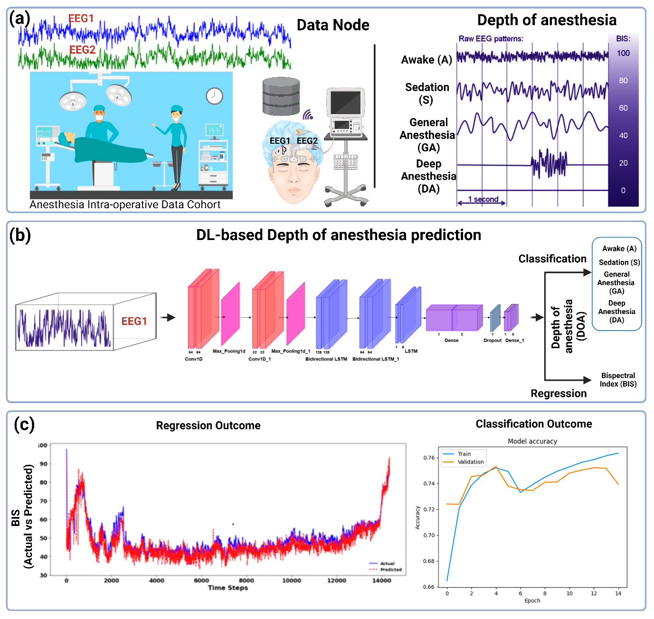Fig. 1
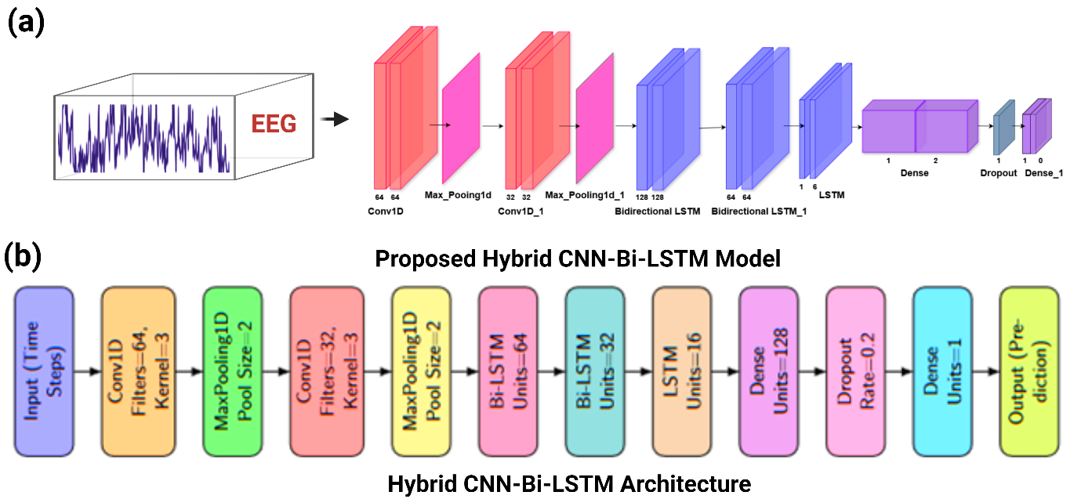
Fig. 2

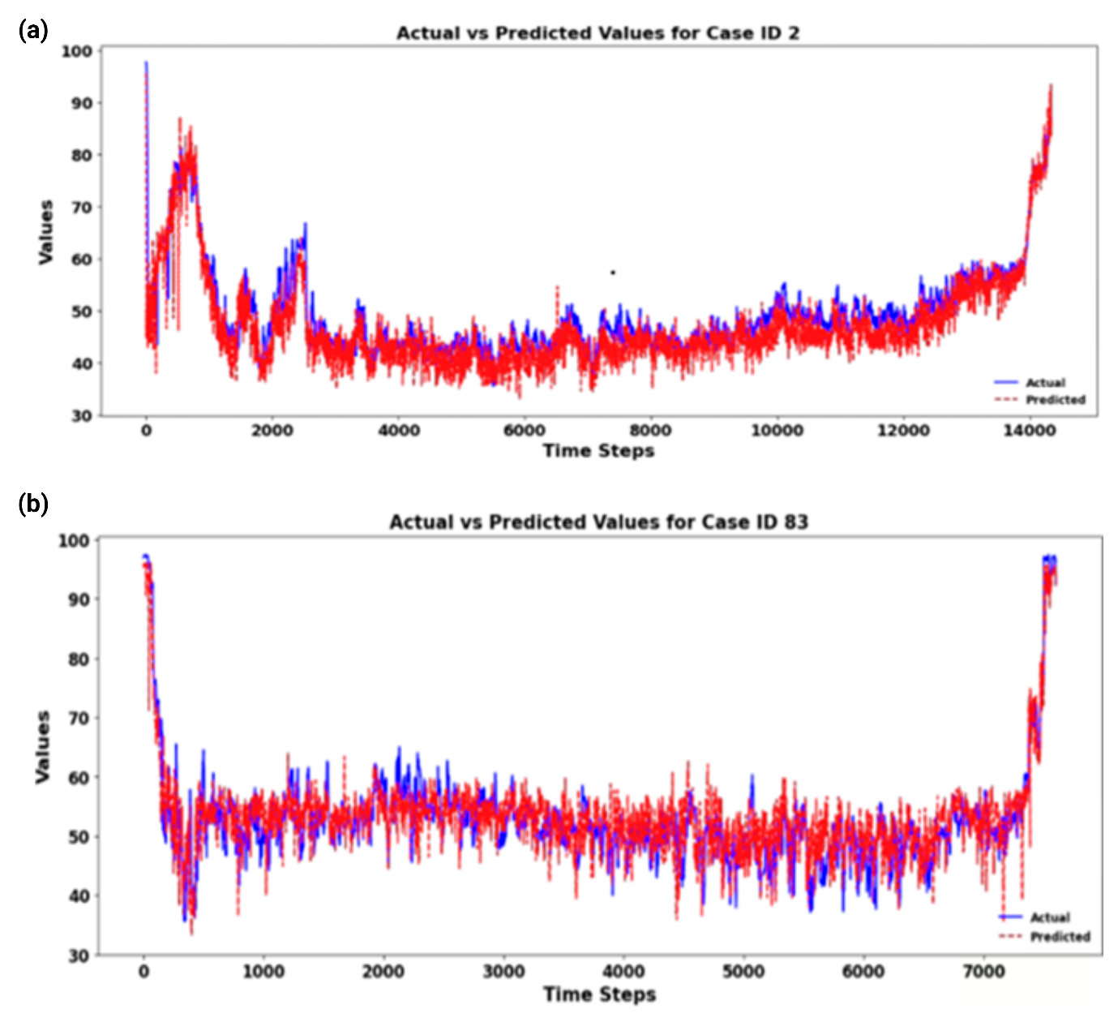

Fig. 3
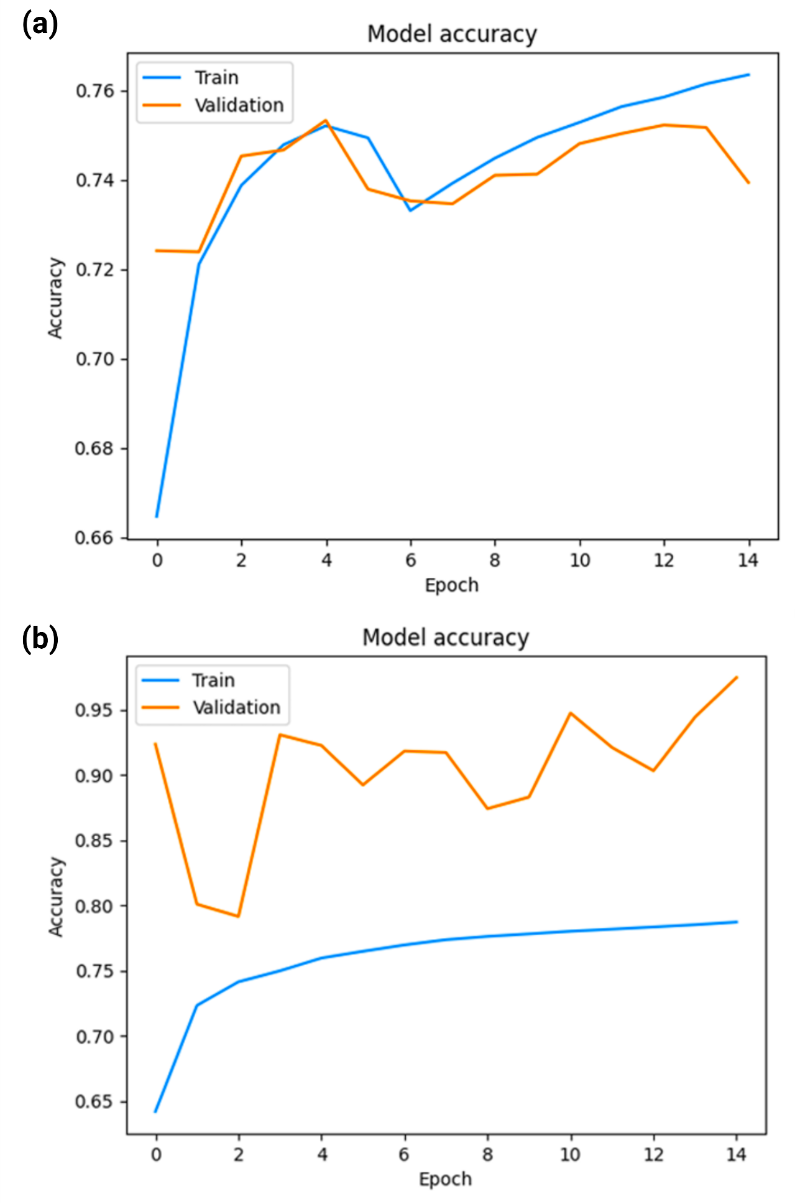
Fig. 4

Table 1. Performance Metrics Results of Deep Learning Classification Models
Model | Accuracy | Precision | Recall | F1-Score
BiLSTM (Imbalanced) | 0.75 | 0.768 | 0.75 | 0.75
BiLSTM (Balanced) | 0.698 | 0.71 | 0.71 | 0.70
Resnet (Balanced) | 0.693 | 0.71 | 0.71 | 0.70

Table 2. Performance Metric Results of Deep Learning Regression Models.
Model | MSE | MAE | RMSE
Proposed Method | 35.20±11.1 | 4.37±0.4 | 5.94±0.8
Sharaf et al. | 98.83±69.29 | 7.38±2.32 | 9.5±2.91
Lieu et al. | 142.31±85.52 | 8.44±2.37 | 11.44±3.38

